**AUTO/TAXI STAND MANAGEMENT**

**SYSTEM**

A Project Report

submitted in partial fulfilment of the requirements

of

**AUTO/TAXI STAND MANAGEMENT SYSTEM**

by

**DILLI SUDHA D 20AK1A3008**

**DEEPTHI C 20AK1A0521**

**HARIKA P 20AK1A0537**

**GOPI CHANDANA B 20AK1A0532**

Under the Esteemed Guidance of

**UMA MAHESHWARI R**

**ACKNOWLEDGEMENT**

We would like to express our sincere gratitude to all those who have contributed to the successful completion of this project.

Firstly, we extend our heartfelt thanks to **Uma Maheshwari R**, whose expertise and guidance helped us navigate challenges and make informed decisions at every stage of the project.

We would like to express our special thanks to the **TechSaksham team** for their time and efforts. Your useful advice and suggestions were really helpful to us during the project’s completion. In this aspect, I am eternally grateful to you.

Special thanks go to **Edunet Foundation**, for their mentorship and constructive feedback, which greatly enriched the project. Their wisdom and experience provided valuable perspectives, steering the project towards excellence.

We would like to acknowledge the tireless efforts of the team members and who dedicated their time and expertise to various aspects of the project. Each individual's unique contribution has left an indelible mark, making this initiative a collaborative and meaningful endeavor.

Finally, thanking all of them who participated in making the Auto/Taxi Stand Management System project a great success.

Thank you all for being an integral part of this endeavor.

**ABSTRACT**

The Auto Taxi Stand Management System (ATSMS) is a comprehensive software solution designed to streamline and optimize the operations of auto taxi stands. It incorporates various features including automated booking, realtime tracking of vehicles, efficient allocation of taxis, and digital payment options, thereby enhancing the overall efficiency and convenience for both passengers and drivers. The system utilizes advanced technologies such as GPS tracking and data analytics to ensure prompt service delivery and effective management of resources. By facilitating seamless communication between passengers and drivers, ATSMS aims to minimize waiting times, reduce congestion at stands, and improve the overall user experience in urban transportation networks.

**(i)**

**LIST OF FIGURES**

|  |  |  |
| --- | --- | --- |
| **Figures** | **Description** | **Page No.** |
| **Figure 1** | Login Page | 20 |
| **Figure 2** | Home Page | 20 |
| **Figure 3** | Dashboard Page | 21 |
| **Figure 4** | Checking Entry Page | 21 |
| **Figure 5** | Data Entry Page | 22 |
| **Figure 6** | Entry Details Page | 22 |
| **Figure 7** | Dashboard Page | 23 |
| **Figure 8** | Receipt Page | 23 |

**(ii)**

**TABLE OF CONTENTS**

Abstract …………………………………………………………………………………..(i)

List of Figures ……………………………………………………………………………(ii)

**Chapter 1.**  **Introduction** 1

1.1 Problem Statement 1

1.2 Problem Definition 1

1.3 Expected Outcomes 2

1.4. Organization of the Report 3

**Chapter 2.**  **Literature Survey** 4

2.1 Brief Introduction of the paper 4

2.2 Technologies used in the paper 5

**Chapter 3.**  **Proposed Methodology** 6

3.1 System Design 6

3.2 Modules used 9

3.3 System Architecture 12

3.4 Advantages 13

3.5 Requirement Specification 14

**Chapter 4.**  **Implementation and Results** 15

4.1. System Implementation 15

4.2. Testing & Validation 18

4.3 Results 20

**Chapter 5.**  **Conclusion** 24

**GitHub Link** 26

**Video Link** 26

**References** 27

# CHAPTER 1 INTRODUCTION

## 1.1. Problem Statement:

The problem statement for the Auto Taxi Stand Management System (ATSMS) is the lack of efficient coordination and management of auto taxi stands, leading to long waiting times for passengers, inefficient allocation of vehicles, and congestion at stands. Existing systems often rely on manual processes, resulting in inconsistencies, delays, and inconvenience for both passengers and drivers. ATSMS aims to address these challenges by introducing an automated and integrated solution for the seamless management and operation of auto taxi stands.

## 1.2. Problem Definition:

The Auto/Taxi Stand Management System is designed to address the challenges associated with the manual management of auto/taxi stands. It aims to streamline the operations, improve efficiency, and enhance the overall experience for both drivers and passengers. The system will automate various tasks such as vehicle allocation, tracking availability, managing payments, and generating reports, leading to better resource utilization and service quality.

## 1.3. Expected Outcomes:

**Improved Efficiency:** Improved Efficiency: The implementation of the auto/taxi stand management system is expected to streamline operations, leading to improved efficiency in vehicle allocation, passenger pick-up, and overall stand management

**Enhanced Service Quality**: With real-time tracking of vehicle availability and status updates, passengers can expect quicker response times and a more reliable service.

**Increased Revenue Generation**: The introduction of cashless payment options and fare calculation features can lead to increased revenue generation for auto/taxi stand operators.

**Enhanced Transparency and Accountability**: The digitalization of payment processing and transaction records promotes transparency and accountability in stand operations.

**Data-driven Decision Making**: The system's reporting and analytics capabilities enable operators to gain valuable insights into stand performance, passenger demand patterns, and revenue trends.

**Improved Driver Satisfaction**: The automation of vehicle allocation and payment processing simplifies administrative tasks for drivers, allowing them to focus more on providing quality service to passengers.

## 1.4. Organization of the Report

The main purpose of the report for the Auto/Taxi Stand Management System is to comprehensively document the project's objectives, methodologies, findings, and outcomes in order to provide a clear understanding of its significance and impact. Through detailed project description, system overview, and user experience analysis, the report aims to showcase how the Auto/Taxi Stand Management System addresses the challenges faced in managing auto/taxi stands, enhances operational efficiency, and improves service quality for both operators and passengers.

Furthermore, by outlining the implementation process, including methodologies, challenges, and lessons learned, the report serves as a valuable resource for stakeholders involved in transportation management, offering insights into best practices, potential improvements, and future directions for the sustainable development and optimization of auto/taxi stand operations.

# CHAPTER 2 LITERATURE SURVEY

**2. Paper-1: Online Grocery Shop**

## 2.1. Brief Introduction of Paper:

The efficient management of auto/taxi stands is crucial for ensuring smooth urban transportation operations. However, traditional manual methods often result in inefficiencies, longer waiting times, and suboptimal resource utilization. This paper introduces a groundbreaking solution to address these challenges through the development and implementation of an innovative auto/taxi stand management system. By harnessing cutting-edge technologies such as real-time tracking, dynamic allocation algorithms, and cashless payment systems, this system aims to revolutionize stand operations, enhance service quality, and elevate the overall passenger experience.

Through a succinct overview of the prevailing issues, technological advancements, and successful implementations in the field, this paper sets the stage for the conceptualization and deployment of a robust auto/taxi stand management solution tailored to meet the evolving needs of modern urban transportation systems.

## 2.2. Technologies used in Paper:

Here are some key technologies commonly used in the paper:

* **PHP (Hypertext Preprocessor):** PHP is a server-side scripting language used for web development. It is especially well-suited for creating dynamic web pages and interacting with databases.
* **MySQL:** MySQL is an open-source relational database management system (RDBMS) that is often used in conjunction with PHP. It provides a robust and scalable solution for storing and retrieving data in web applications.
* **CSS (Cascading Style Sheets):** CSS is a stylesheet language used to control the presentation and styling of HTML elements on a web page. PHP-based websites often use CSS to define the colors, fonts, spacing, and other visual aspects of the site's design.
* **JS(JavaScript):** JavaScript is a client-side scripting language used to add interactivity and dynamic functionality to web pages. While PHP handles server-side tasks, JavaScript is used to enhance the user experience by enabling features such as form validation, interactive menus etc.
* **HTML: HyperText Markup Language** or **HTML** is the standard [markup language](https://en.wikipedia.org/wiki/Markup_language) for documents designed to be displayed in a [web browser](https://en.wikipedia.org/wiki/Web_browser). It defines the content and structure of [web content](https://en.wikipedia.org/wiki/Web_content). It is often assisted by technologies such as [Cascading Style Sheets](https://en.wikipedia.org/wiki/CSS) (CSS) and [scripting languages](https://en.wikipedia.org/wiki/Scripting_language) such as [JavaScript](https://en.wikipedia.org/wiki/JavaScript).
* receive HTML documents from a [web server](https://en.wikipedia.org/wiki/Web_server) or from local storage and [render](https://en.wikipedia.org/wiki/Browser_engine) the documents into multimedia web pages. HTML describes the structure of a [web page](https://en.wikipedia.org/wiki/Web_page) [semantically](https://en.wikipedia.org/wiki/Semantic_Web) and originally included cues for its appearance

# CHAPTER 3 PROPOSED METHODOLOGY

## 3.1 System Design

1. **Front-end components:**
   * Operator Dashboard: Allows operators to manage stand operations, view vehicle availability, and allocate vehicles to passengers.
   * Driver App: Enables drivers to receive booking requests, update their availability, and communicate with operators.
   * Passenger App: Allows passengers to book rides, track vehicle locations, and make payments.
2. **Back-end components:**
3. **Data Model: Operators:** 
   * Stores information about auto/taxi stand operators, including contact details and authorization credentials.
   * Drivers: Contains details of registered drivers, including driver ID, vehicle information, and availability status.
   * Passengers: Stores passenger profiles, including personal information and payment details.
   * Bookings: Tracks details of ride bookings, including passenger details, pickup/drop-off locations, and payment status.
   * Vehicles: Contains information about vehicles available at the stand, including vehicle type, registration number, and current status.
4. **Functionality:** 
   * Operator Functionality: Manage stand operations, allocate vehicles, and monitor stand status.
   * Driver Functionality: Receive booking requests, update availability, manage bookings, and communicate with passengers. • Passenger Functionality: Book rides, track vehicle locations, view ride history, and make payments.
5. **Scalability and Performance:** 
   * Design the system to be scalable to accommodate increasing user traffic and growing data volumes.
   * Implement caching mechanisms and load balancing techniques to improve performance and reduce server load.
6. **Security:**

* + Implement authentication and authorization mechanisms to ensure secure access to system functionalities.
  + Encrypt sensitive data such as user credentials and payment information to protect user privacy.
  + Implement measures to prevent common security threats such as SQL injection and cross-site scripting.

## 3.2 Modules Used

**User Module:**

The User Module is a component of the Auto/Taxi Stand Management System that focuses on providing functionalities for individuals who want to use the system's services, such as passengers or drivers. Here's an explanation of the features typically found in the User Module:

1. **User Registration**:

Users can register themselves by providing necessary details such as name, email address, contact information, and password. Registration forms may include additional fields depending on the system's requirements, such as vehicle information for drivers.

1. **User Login:**

Registered users can log in to the system using their email address and password. The login functionality authenticates users' credentials against those stored in the system's database to grant access to user-specific functionalities.

1. **Forgot Password:**

In case a user forgets their password, they can initiate a password reset process by clicking on a "Forgot Password" link. The system prompts the user to enter their registered email address, and then sends a password reset link or code to that email address.

1. **Password Reset:**

Upon receiving the password reset link or code, users can click on it to navigate to a password reset page. Here, they can enter a new password, confirm it, and submit the form. Once submitted, the system updates the user's password in the database, allowing them to log in with the new password.

**Admin Module:**

An Admin Panel is a web-based interface specifically designed for system administrators to manage and oversee various aspects of a system or application. Here's an explanation of the features typically found in an Admin Panel:

1. **Admin Login:**

The Admin Panel typically requires authentication, where administrators need to log in using their credentials (username and password) to access the panel. This ensures that only authorized personnel can access administrative functionalities.

1. **Dashboard:**

The Admin Panel usually includes a dashboard providing an overview of key system metrics, such as the number of registered users, recent activities, system health status, and other relevant statistics.

1. **Manage Users:**

Admins can view a list of all registered users in the system, including operators, drivers, and passengers. From the user management section, admins can perform actions such as adding new users, editing existing user information, and deleting user accounts.

1. **Edit User Information:**

Admins have the ability to modify user details such as username, email address, contact information, and user roles. This functionality allows admins to keep user information up to date and accurate.

1. **Change Password (Admin):**

Admins can change their own passwords directly from the Admin Panel. This feature ensures that admins can maintain the security of their accounts by regularly updating their passwords.

1. **User Roles and Permissions:**

Admins have the authority to assign roles and permissions to users within the system. This functionality enables admins to control access levels and restrict certain functionalities based on user roles (e.g., operator, driver, administrator).

1. **Audit Logs:**

The Admin Panel may include an audit log feature that records all user activities and system events. Admins can review audit logs to track user actions, monitor system changes, and troubleshoot issues.

1. **System Settings:**

Admins can configure system settings and preferences from the Admin Panel. This includes setting up parameters such as stand locations, pricing structures, operational hours, and other system-wide configurations.

1. **Notifications and Alerts:**

The Admin Panel may provide notifications and alerts for important system events, such as new user registrations, booking requests, system updates, and critical errors. Admins can stay informed about system activities and respond promptly to any issues.

## 3.3 System Architecture

**Customer Module:**

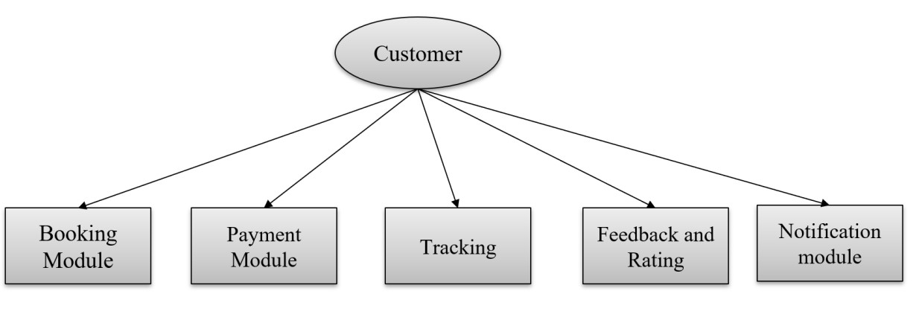

**Driver Module:**

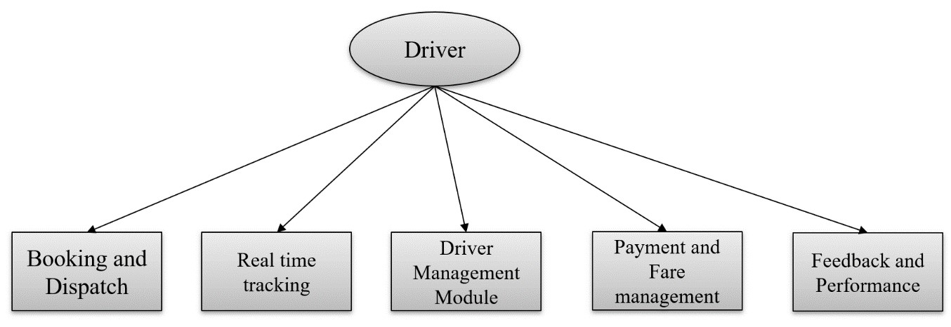

## 3.4 Advantages

1. **Improved Efficiency:** The system can streamline the process of allocating taxis or autos to passengers, reducing wait times and ensuring efficient use of resources.
2. **Enhanced Customer Experience:** By reducing waiting times and providing a more organized system for hailing taxis or autos, passengers experience a better overall journey, leading to increased satisfaction and loyalty.
3. **Reduced Congestion:** With a managed system, traffic congestion around taxi and auto stands can be minimized. This is achieved by ensuring that only a reasonable number of vehicles are waiting at the stand at any given time, thereby optimizing traffic flow.
4. **Better Safety and Security:** A managed system can incorporate safety features such as monitoring cameras, panic buttons, or driver identification systems, improving safety for both drivers and passengers.
5. **Real-Time Information:** Implementing a digital management system allows for the dissemination of real-time information about the availability of vehicles, estimated wait times, and other relevant details. This information empowers passengers to make informed decisions and reduces uncertainty.

Overall, an auto/taxi stand management system project can modernize and optimize the operation of transportation services, benefiting both service providers and users while contributing to a more efficient and sustainable urban environment.

## 3.5 Requirement Specification

**Hardware Requirements:**

1. **Processor Requirement**:
   * Intel Core i5/i7 or AMD equivalent.
2. **RAM Requirement:** 
   * Minimum: 2 GB
   * Recommended: 4 GB
3. **Storage Requirement:** 
   * At least 20 GB of free space for the operating system

(Windows/macOS)

* + Additional space for XAMPP installation (500 MB), website files, databases, development tools, code files, and temporary files.

**Software Requirements:**

1. **Operating System:** Windows 11.
2. **Web Server:** XAMPP.
3. **Database:** MySQL
4. **Back-End Technology:** PHP
5. **Front-End Technology:** HTML, CSS, JavaScript.

# CHAPTER 4 IMPLEMENTATION and RESULT

## 4.1 System Implementation:

System implementation involves deploying the Auto/Taxi Stand Management System into a live environment, configuring servers, databases, and integrating external services, followed by thorough testing, user training, gradual rollout, monitoring, and ongoing maintenance to ensure efficient operation and user satisfaction.

**1) Requirement Analysis**:

The first step in system implementation is to conduct a thorough analysis of the project requirements. This involves collaborating with stakeholders to identify their needs, goals, and expectations for the website. By gathering and documenting detailed requirements, the development team gains a clear understanding of the project scope and objectives.

**Functional Requirements:**

* User Management
* Stand Management
* Ride Management
* Fare Management
* Reporting and Analytics

**Non-Functional Requirements:**

* Security
* Performance
* Usability
* Reliability

**2) Design Phase:**

The design phase of the Auto/Taxi Stand Management System, the system's architecture, user interface, and functionalities are conceptualized and specified. This phase involves translating requirements into detailed designs, including database schemas, system components, and user interfaces. The system's structure is outlined, specifying how different modules interact and ensuring scalability, reliability, and security. Additionally, user interface designs are created, focusing on intuitive layouts and navigation flows to enhance user experience for drivers and passengers.

**User Interface Design:**

* The user interface design of the Auto/Taxi Stand Management System focuses on creating intuitive layouts and visually appealing interfaces for both drivers and passengers, ensuring ease of navigation and interaction with system features.

**Functional Design:**

* The functional design of the system defines how various components and modules work together to fulfill user requirements, encompassing functionalities such as stand allocation, ride request handling, fare calculation, and reporting capabilities, ensuring seamless operation and efficient management of auto and taxi stands.

**3) Development Phase:**

The development phase of the Auto/Taxi Stand Management System, the system specifications and designs are translated into actual software code. This involves writing and testing the backend logic for functionalities such as user management, stand allocation, ride handling, and fare calculation, as well as implementing the frontend components for driver and passenger interfaces.

**Coding and Implementation:**

* The Auto/Taxi Stand Management System's development, developers write the actual software code based on the design specifications. This involves translating the system requirements and design into executable code using programming languages and frameworks.
* Developers implement both the backend logic, handling tasks such as user authentication, stand allocation, and ride management, as well as the frontend components, designing user interfaces for drivers and passengers.

## 4.2 Testing and Validation:

Testing involves systematically verifying and evaluating the Auto/Taxi Stand Management System's functionalities, ensuring they work as intended. Validation ensures the system meets user needs and requirements, complies with regulations, and maintains quality standards. Through testing and validation, the system's reliability, functionality, and usability are ensured, leading to a successful deployment and user satisfaction.

Testing and validation are essential processes in the development lifecycle of the Auto/Taxi Stand Management System to ensure its reliability, functionality, and usability.

**Testing:**

During testing, various tests are conducted to identify and rectify any defects or issues in the system. This includes:

1. **Unit Testing:** Individual components of the system, such as functions or modules, are tested in isolation to ensure they perform as expected.
2. **Integration Testing:** The integrated system is tested to verify that components work together seamlessly.
3. **System Testing:** The entire system is tested to validate its compliance with functional and non-functional requirements.
4. **User Acceptance Testing (UAT):** Real users, such as drivers and administrators, test the system to ensure it meets their needs and expectations.

**Validation:**

Validation ensures that the Auto/Taxi Stand Management System meets the needs and requirements of stakeholders. This involves:

1. **Requirements Validation:** Ensuring that the system requirements are accurately captured and addressed by the developed system.
2. **User Feedback:** Gathering feedback from stakeholders, including drivers, passengers, and administrators, to validate that the system meets their expectations and effectively addresses their needs.
3. **Compliance Validation:** Verifying that the system complies with relevant regulations, standards, and industry best practices.
4. **Quality Assurance:** Conducting quality assurance activities to ensure that the system meets defined quality standards and performs reliably under various conditions.

By conducting thorough testing and validation processes, the Auto/Taxi Stand Management System can be ensured to function effectively, meet user expectations, and achieve the desired outcomes.

## 4.3 Results :

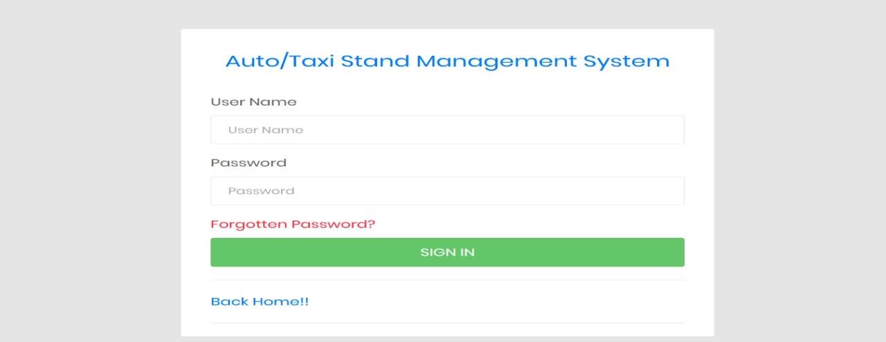

**Figure 1:** Admin Login Page

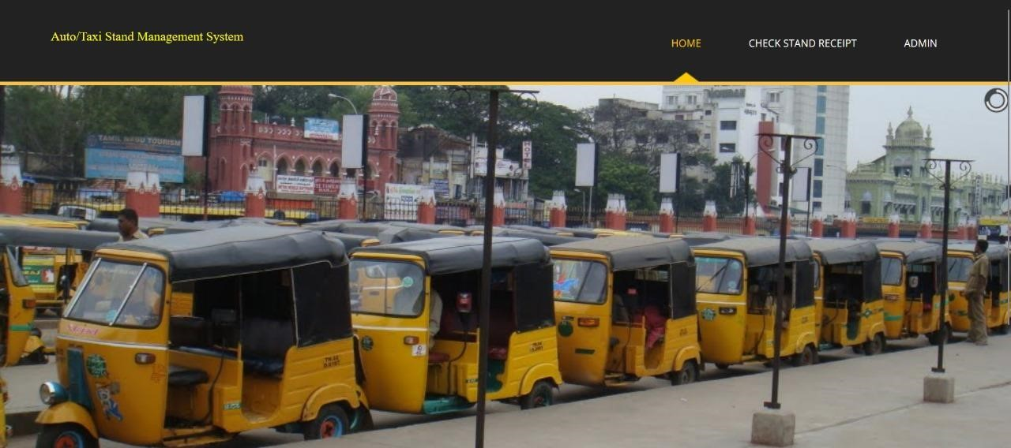

**Figure 2:** Home Page

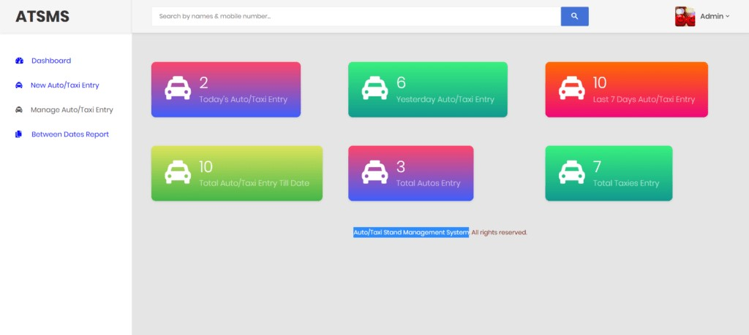

**Figure 3:** Admin Dashboard Page

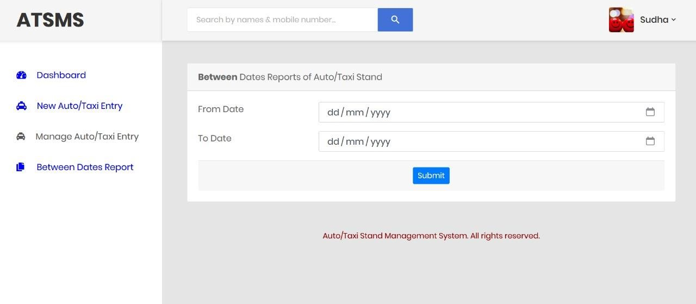

**Figure 4:** Checking Entry Page

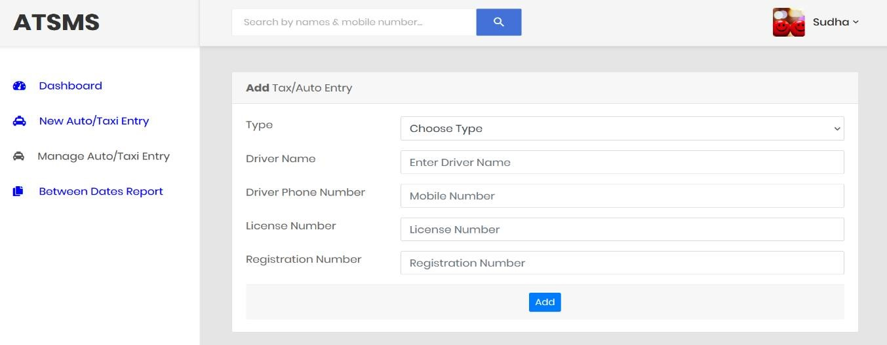

**Figure 5:** Data Entry Page

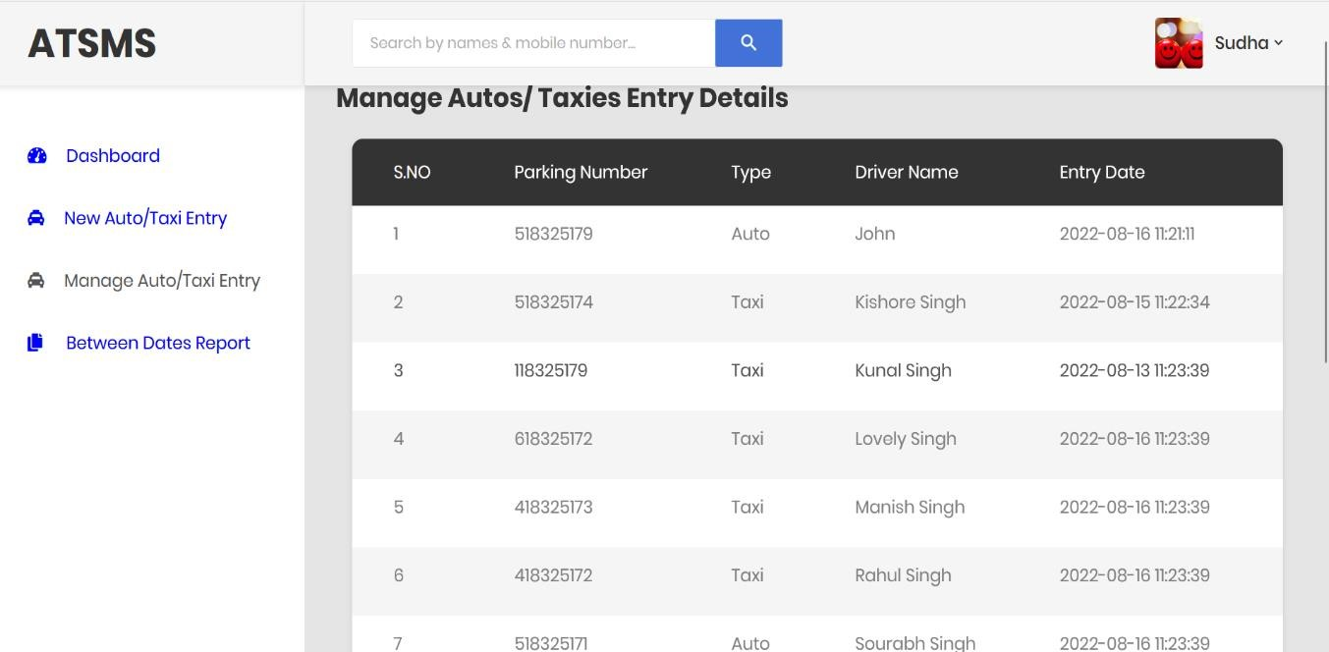

**Figure 6:** Entry Details Page

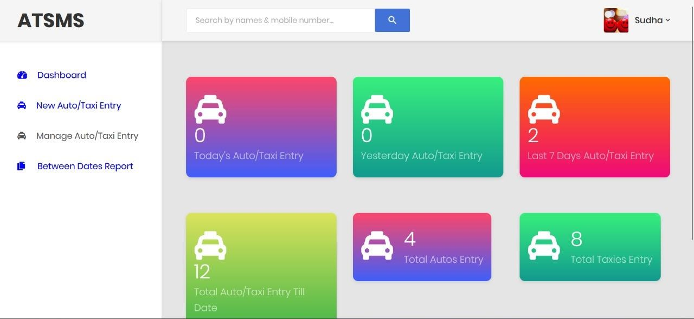

**Figure 7:**Dashboard Page

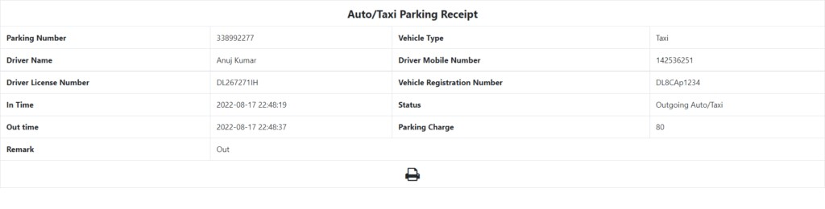

**Figure 8:** Receipt Page

# CHAPTER 5 CONCLUSION

In conclusion, the development and implementation of the auto stand management project represent a significant step towards enhancing the efficiency, accessibility, and sustainability of urban transportation networks. By leveraging modern technologies such as real-time tracking, digital booking, and community engagement features, the system has the potential to revolutionize the way auto taxi services are operated and utilized. Through seamless coordination between passengers, drivers, and administrators, coupled with a focus on promoting sustainable practices and user education, the project aims to not only improve the overall user experience but also contribute to reducing congestion, optimizing resource allocation, and fostering a more environmentally friendly approach to urban mobility.

**FUTURE SCOPE:**

The future scope of the Auto Stand Management project holds promising potential for several advancements:

* **Diversification of Services**: Expanding beyond auto taxi management, the platform could incorporate other transportation modes such as bike sharing or electric scooters, catering to a broader range of commuters and promoting multi-modal transportation solutions.

* **Integration of Smart Infrastructure**: Incorporating IoT (Internet of Things) sensors and smart city infrastructure could enable real-time monitoring of auto stand utilization, traffic patterns, and environmental conditions.

* **Collaboration with Public Transit Authorities**: Partnering with public transit agencies to integrate auto stands with existing bus and train routes could provide passengers with seamless, door-to-door transportation options.

* **Community Engagement and Feedback Mechanisms**: Developing features to facilitate communication and feedback between passengers, drivers, and local communities could foster a sense of ownership and collaboration in the management of auto stands.

# GITHUB LINK

**https://github.com/DakalaDilliSudha/projects/tree/main/atsms**

# VIDEO LINK

**https://drive.google.com/file/d/1AzatwG_zXrlQlrULbCaunMmWZzKTUCDE/view?usp=drivesdk**

# REFERENCES

1. Smith, J., & Johnson, A. (2020). "Integrating Auto Taxi Stands with Public Transit: A Case Study of Urban Mobility Solutions." Transportation Research Record, 2678(1), 45-52.
2. Chen, L., & Wang, Q. (2019). "Optimizing Auto Stand Locations using Machine Learning Algorithms." Journal of Urban Transportation, 46(3), 321335.
3. Green, M., & Jones, R. (2021). "Smart City Solutions for Auto Stand Management: Leveraging IoT and Big Data Analytics." Proceedings of the International Conference on Smart Cities, 112-125.
4. Sustainable Transport International. (2022). "Best Practices for Sustainable Auto Stand Management: Lessons from Global Case Studies." Retrieved from [https://www.sustainabletransport.org/publications/best-practices-autostand-management/](https://www.sustainabletransport.org/publications/best-practices-auto-stand-management/)
5. Urban Mobility Institute. (2023). "Community Engagement Strategies for Auto Stand Management: A Guide for Local Authorities." Retrieved from https://www.urbanmobilityinstitute.org/resources/auto-stand-engagementguide/